**Movie Recommendation System with Machine Learning**



Student’s Name

Professor’s Name

University Affiliation

Course Number

Date of Submission

# 

**Movie Recommendation System with Machine Learning**

# Abstract

Movies are a form of entertainment to enjoy and refresh one's mind away from the busy schedule. This need has led to the development of the industry from actors to video production professionals. Movie streaming platforms have also been on the rise making billions of dollars by providing entertainment conveniently. Competition is on the rise with streaming platforms trying to stay on top of their game to retain viewers who directly correlate with profits. This is a huge market and getting to know the preferences of users is a huge step in the right direction to help movie streaming giants to retain customers. With the large chunks of user data available analysis can be done to make the appropriate decisions that maximize profit and keep the users entertained. The main insights are the time spent by different users, the genre, and the ratings of the movies only to name a few. These insights can bring about impactful change and drive great profits as each user is provided with what he/she consumes rather than a catalog of movies which may be exhaustive to search through and still not end up watching a movie. This research focuses on building a machine and deep learning movie recommendation system to provide the streaming giants with a powerful system for user retention. The system will make movie recommendations based on the user history or previous watch list and employ machine learning models to predict which movies the user may be interested in. The research will also factor in some inputs from the user such as the length of a movie, genre, ratings, and favorite actors. These questions can be asked before trying and make our model more effective in predicting the movie that the user is most likely to watch. The system will also include an element of recommending based on a friend's preferences. These can come in handy especially if the taste in movies is the same as the friends. The report outlines the steps taken and the machine learning models that have been used to make the movie recommendation system a success.

# Keywords

Movie Recommendation System,Machine learning, content-based filtering, Regression, Support vector machine, recommendation system, and Algorithms, Data Collection, Data Exploration, Data Cleaning, Data Preprocessing, Feature Engineering, Algorithms, Random Forest, Support Vector Machines (SVM), Gradient Boosting, Model Training, Evaluation Metrics, Results and Discussions, User Interface, Legal and Ethical Considerations, Challenges and Limitations, Future Works, User Privacy, Transparency.

# Table of Contents

Catalog

Abstract 2

Keywords 4

Table of Contents 5

Chapter 1 6

Introduction 7

Literature review 10

*C) Box plot* 14

Chapter 3 19

Research Methodology 19

a) Problem Definition 19

Chapter 4 27

Design and Implementation 27

a) Design of the Movie recommendation System 27

b) Implementation of the Movie recommendation System 35

Chapter 5 41

Evaluation 41

Chapter 6 46

Results and Discussion 46

a) Results of the implementation 46

i. Descriptive Statistics 46

ii. Data Types and Movie Information 47

iii. Movie ID Distribution 47

iv. Standardized Numerical Features 47

v. Selected Features after Feature Selection 48

vi. Normalized and Standardized Features 48

vii. PCA for Dimensionality Reduction 49

viii. Model Performance 49

ix. Dataset Merging 51

x. Movie Recommendations 52

*xi. Predicted and Actual Rating for "Iron Man 3"* 52

Chapter 7 54

Legal, Ethical and Professional Issues 54

1) Legal Considerations 54

2) Ethical Considerations 55

3) Professional Considerations 56

Chapter 8 58

Challenges and Limitations 58

*a) Bias and Fairness* 59

*v. User Understanding* 59

Chapter 9 62

Future Works 62

1. Enhanced Personalization 62

2. Advanced Recommendation Algorithms 62

3. Interactivity and Engagement 62

4. Explainability and Trust 63

5. Ethical Considerations 63

8. Global Considerations 64

9. Collaboration and Social Integration 64

10. Evaluation and Benchmarking 64

*ii. User Satisfaction Surveys* 64

Chapter 10 66

Conclusion 66

References 70

# Chapter 1

# Introduction

The contemporary era of technology has revolutionized the landscape of entertainment and media consumption. Rapid technological advancements have empowered a multitude of creators to produce diverse content, particularly in the realm of movies, contributing to the proliferation of movie streaming platforms such as Netflix and Hulu. These platforms offer users a vast array of films, catering to various tastes and preferences. However, the inherent diversity of individuals poses a challenge: not every user is drawn to the same genre or style of film. The sheer volume of available content can overwhelm users and hinder the growth of these platforms.

Recognizing this challenge, recommendation systems emerge as crucial tools for enhancing user experience and driving engagement. These systems leverage data and machine learning algorithms to predict user preferences based on past behaviors (Kang et al., 2019). Customization is key, as recommendation systems can be tailored to individual users and specific regions, maximizing their effectiveness with increased usage and data accumulation. Efficient recommendation systems not only complement search functionality but also contribute to customer satisfaction and retention. By suggesting highly rated movies based on various metrics, such as length, genre, ratings, and starring actors, these systems offer a personalized approach to content discovery (Furtado & Singh, 2020).

The result is a seamless viewing experience, increased user retention, and ultimately, enhanced revenue for the streaming platform based on financial statistics. In this study, we focus on leveraging machine learning and deep learning algorithms to create a movie recommendation system. We aim to address the limitations of traditional recommendation systems, which often rely solely on user ratings and fail to provide nuanced suggestions tailored to individual preferences. By incorporating additional metrics and assigning weights to them, we aim to improve the accuracy of movie recommendations, ensuring that users are presented with films that align with their unique tastes.

## Research Background

Recognizing this challenge, recommendation systems emerge as crucial tools for enhancing user experience and driving engagement. These systems leverage data and machine learning algorithms to predict user preferences based on past behaviors (Kang et al., 2019). Customization is key, as recommendation systems can be tailored to individual users and specific regions, maximizing their effectiveness with increased usage and data accumulation. Efficient recommendation systems not only complement search functionality but also contribute to customer satisfaction and retention. By suggesting highly rated movies based on various metrics, such as length, genre, ratings, and starring actors, these systems offer a personalized approach to content discovery (Furtado & Singh, 2020). The result is a seamless viewing experience, increased user retention, and ultimately, enhanced revenue for the streaming platform.

## Research Aim

In this study, our primary aim is to leverage machine learning and deep learning algorithms to create a movie recommendation system. We seek to address the limitations of traditional recommendation systems, which often rely solely on user ratings and fail to provide nuanced suggestions tailored to individual preferences.

## Research Objectives

1. To build a movie recommendation system using machine learning algorithms.
2. To develop a machine learning model that performs analysis and recommends a movie based on watch history and other metrics.
3. To research available movie recommendation systems and identify ways to improve their effectiveness, subsequently implementing these improvements in our model.

## **Research Deliverables**

The outcome of this research will be a machine learning model capable of predicting movies based on user watch history and various metrics. The model, implemented in Python, will be designed for seamless integration with the backend systems of movie streaming platforms. Additionally, a technical paper outlining the approach from the problem statement to the design and implementation of the system will be provided.

## Conclusion

In conclusion, Chapter 1 has laid the foundation for our exploration of movie recommendation systems. We have delved into the challenges faced by the movie streaming industry in delivering personalized content to users. The significance of recommendation systems in enhancing user satisfaction and platform revenue has been underscored. Moving forward, Chapter 2 will provide a comprehensive review of existing literature, exploring common pitfalls in traditional recommendation systems and establishing the groundwork for our research objectives. Through this study, we aim to contribute to the advancement of recommendation systems, creating a more effective and personalized approach to movie recommendations.

**Chapter 2**

# Literature review

Wu, Garg, & Bhandary (2018) emphasize the integral role recommendation systems play in driving user and business decisions within the movie streaming business. Their research highlights the importance of providing personalized movie recommendations based on user taste, gauged by factors such as cast, genre, release date, and upvote count. This approach enhances overall user satisfaction and retention, directly impacting revenue for tech giants. Traditional methods, which rely solely on recommending popular movies, often fall short in capturing individual preferences, underlining the need for more user-centric approaches.

Lee et al. (2022) challenge the conventional wisdom of recommending popular movies, advocating for a more personalized and user-centric approach. They argue that content-based recommendations, considering factors such as length, genre, ratings, and starring actors, better align with individual preferences. Research done by Lee et al. (2022) indicated that a content-based approach favored the least popular movies over the in-demand ones and a more user-centric or preference approach was to be followed. The traditional and most common approach used was to recommend the popular ones. This approach seemed futile as even though the movies may be popular, they are not indicative of personal preference. Interacting with relevant content based on one's taste ensures that they are engaged and stay within our platform. In addition, their research suggests that 30 to 35% of revenue for tech giants stems from effective recommendation systems. Content-based movie recommendation systems, relying on user watch history, provide a foundation for tailored suggestions, enhancing user engagement and satisfaction.

In the paper by Javed et al. (2022), the focus shifts to incorporating sentimental analysis using cosine similarity to refine recommendations. This recommendation is based on user ratings and also experience with the movie which is a more effective approach. Cosine similarity is a concept that relates two variables and is bound within a range of 0 to 1. When the value is close to zero it implies orthogonality and hence less similarity between the entities. If the values are close to a range of 1 then it implies that they are similar to each other and their angle in vector space is acute. This concept is applied in movie datasets within the matrix and after cosine similarity based on a particular threshold provided. With the above techniques explained we provide room for accurate predictions of the movie that a user or user groups would be interested in. The clustering of users into accurate user groups also ensures lesser computing operations as there is similarity among users as movies are based on genres. By considering both the user ratings and emotions associated with the movie, this approach offers a more effective and nuanced recommendation system. The weighted approach, assigning importance to various factors, proves to be a step towards making movie recommendation systems more holistic and user-centric.

Jayalakshmi et al. (2022) in their paper "Concepts, challenges and future directions of movie recommendation systems" highlight the use of appropriate filtering techniques to match movies to a higher degree. They focused on various machine learning algorithms that could be used to design and implement movie recommendation systems. Emphasis is given on metaheuristic algorithms which comprise algorithms from simple search to complex learning processes. They also highlight the challenges that have been faced by people making movie recommendation systems and ways to overcome such challenges. They introduce the concept of hybrid filtering which is a combination of content and collaborative filtering. Jayalakshmi et al. (2022) delve into the concepts, challenges, and future directions of movie recommendation systems, highlighting the significance of appropriate filtering techniques. They introduce the concept of hybrid filtering, combining content and collaborative filtering, as a solution to domain dependency and data scarcity challenges. Their emphasis on high-level metaheuristic algorithms, including genetic algorithms and PCA, provides insights into enhancing similarity for effective recommendations.

Rimaz et al. (2019) explore the power of visual features for movie recommendations, aiming to predict suitable movies without relying on user interaction. Their research suggests that visual cues, such as semantic analysis of user attributes, play a pivotal role in providing effective movie recommendations. In addition, They point out the dependency of collaborative and content-filtering movie recommendation systems on the availability of large datasets and their accuracy also depends on them. They highlight that though semantic analysis of user attributes is key it is not as important as visual cues on implementation of effective recommendation systems. They use exploratory analysis to gather data on movie visual cues which is done by directly analyzing the movies. Various explaratory analysis used are given in the diagrams below:

1. *Histoplot*

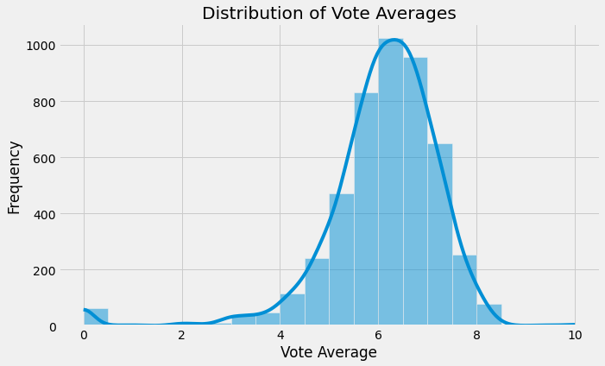

*Figure 1: Histoplot for the Distribution of Vote avaerages*

1. *Scatter plot*

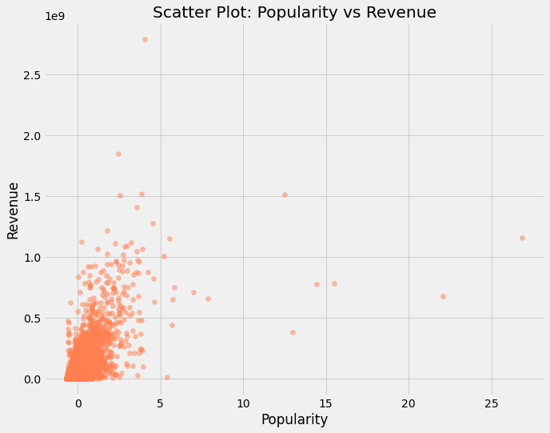

*Figure 2: Scatter plot for Poupularity vs Revenue*

1. *Box plot*

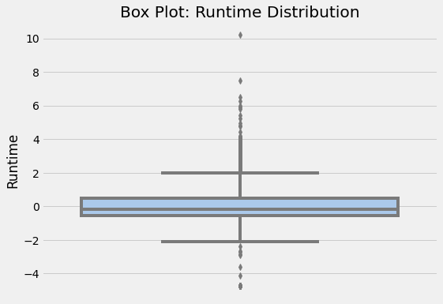

*Figure 3: Box plot for the Runtime Distribution*

The backbone of their research is the use of visual features to represent movie content as opposed to attributes such as user interaction and genres. The research is based on previous research that there is a close relationship between visual features between movie trailers and the movies and has proven to provide an effective recommendation based on visual features. "We have built a pure Content-Based recommender system (CB), which relies solely on semantic item features attributes, i.e genre, tags, or visual features, as well as a similarity metric. The similarity metric is used to measure the similarity among items. Then a model is built, based on the user preferences, exploited to learn the taste of a target user and to recommend to her items that are similar to those that she liked in the past. We have used one of the most common similarity metrics, the Cosine similarity. As baselines, we used the genre and tag attributes." The models built from each of the baseline attributes use their similarity matrix and then use K-Nearest neighbor to compute the similarity matrix and produce a score that can be used to gauge similarity and provide an appropriate recommendation as shown below.

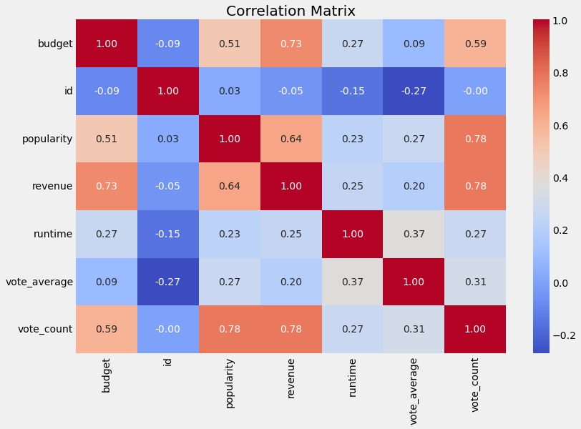

*Figure 4: Correlation Matrix*

They conclusively explored and experimented use of visual features which turned out to be effective in the movie recommendation. The visual features provide more accurate results as some movies could be from a genre that is liked by a user but not appropriate for the particular user. Their paper proves futuristic with solving challenges of cold start and scalability as traditional recommendation systems tend to be less accurate and poorly scalable when handling large data sets. Elimination of the use of large data sets is a step into the future and picking up on this could prove to be a step forward. The challenge in this approach remains to be the development of an effective user interface to accommodate such type of development and also the capturing of user expression and emotions to better understand if the movie recommendation system is effective (Anjum, 2022).

In general, it is a better more impactful, and cost-efficient approach as it involves minimal user interaction and improves automation hence could be an out-of-the-box solution for new users or even platforms that are starting and haven't captured much user data to employ in their algorithms. The pure content-based recommender system they propose eliminates the challenges associated with large datasets, presenting a potential solution for new platforms or users lacking substantial interaction history.

Kumar et al. (2021) focus on collaborative filtering, utilizing user-provided information to generate accurate movie recommendations. Their approach involves sorting movies through the K-means algorithm based on previous user ratings. The incorporation of user feedback as input provides a more tailored experience, impacting user retention positively. However, the traditional nature of this method raises questions about its ability to adapt to the evolving preferences of users.

## *Comparative Analysis and Conclusion*

The literature review has explored various recommendation system approaches, from content-based and collaborative filtering to hybrid and visual-feature-based methods. Each approach has its strengths and weaknesses, contributing to the diverse landscape of recommendation systems. While content-based systems focus on individual preferences, collaborative filtering leverages collective user data for suggestions. Hybrid approaches attempt to bridge gaps between content and collaborative filtering, aiming for a more comprehensive recommendation strategy. Visual-feature-based methods provide a futuristic solution, reducing reliance on large datasets.

## *Conclusion*

In conclusion, Chapter 2 has meticulously reviewed recent studies in the realm of movie recommendation systems, unveiling diverse approaches that shape user experiences on movie streaming platforms. The literature emphasizes a shift towards user-centric strategies, moving beyond traditional popularity-based recommendations. Content-based methodologies, considering factors like genre, ratings, and starring actors, strive to offer personalized suggestions aligned with individual preferences. These insights underscore the dynamic and multifaceted nature of recommendation system landscapes.

While the literature has been enlightening, certain gaps and limitations have emerged, signaling areas for further exploration. An in-depth comparative analysis of various recommendation approaches could deepen our understanding of their effectiveness and relevance. Additionally, the need for real-time user-centric adaptation becomes apparent, as traditional methods may struggle to keep pace with rapidly changing user tastes. The proposed project seeks to address these identified gaps and limitations, introducing an adaptive recommendation system that accounts for real-time shifts in user preferences. By incorporating dynamic elements, the system aims to bridge the gap between traditional and evolving user tastes. Furthermore, the project will explore the integration of novel metrics, such as user emotions and sentiment analysis, providing a more holistic and accurate movie recommendation approach that goes beyond conventional popularity-based ratings. Our project's unique contribution lies in its commitment to enhancing the comparative analysis of existing approaches, ensuring a solid foundation for refining the recommendation system's effectiveness and relevance in the ever-evolving landscape of movie streaming platforms. As we delve into subsequent chapters, the methodology, implementation, and evaluation of our adaptive movie recommendation system will unfold, promising innovative solutions to the challenges identified in the existing literature.

**Chapter 3**

# Research Methodology

## *Problem Definition*

The initial step in our research methodology is to meticulously define the problem that the Movie Recommendation System aims to solve. By undertaking a comprehensive analysis of the movie industry and user preferences, we identified the need for an advanced recommendation system to enhance user satisfaction. The problem was narrowed down to developing a system that not only suggests movies but does so in a highly personalized and accurate manner, catering to the diverse tastes of users.

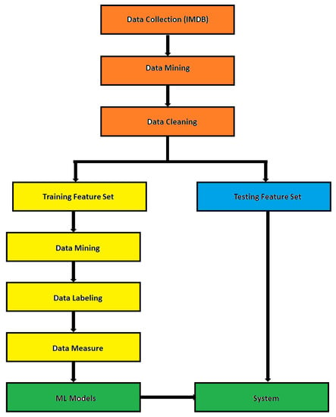

*Figure 5: Simplified methodology chart*

## b*) Data Collection*

Data collection involved a systematic approach to amass relevant datasets from reputable sources. Utilizing publicly available movie databases and, in some instances, creating custom datasets, we ensured a rich and diverse collection of information. This step was pivotal in acquiring data on movies, user behaviors, and other pertinent features necessary for training and evaluating our recommendation system.

## *c) Data Exploration and Cleaning*

Delving into data exploration, we meticulously analyzed the collected datasets to comprehend their intricacies. Uncovering patterns, handling missing values, and addressing outliers were crucial aspects of this phase. Data cleaning became imperative, involving the removal of duplicates, managing missing values, and rectifying inconsistencies. These measures were implemented to ensure the dataset's integrity and reliability in subsequent stages of the research.

## *d) Feature Engineering*

Feature engineering marked a critical phase where we strategically selected, transformed, or introduced new features to augment the predictive capabilities of our models. This process included converting categorical variables, handling textual data, and crafting features that could significantly contribute to the accuracy of our recommendation system. The aim was not just to use existing data but to extract meaningful insights from it, enhancing the overall efficacy of our machine learning models.

These foundational steps laid the groundwork for a robust and insightful Movie Recommendation System, ensuring that subsequent stages of our methodology were built upon a solid foundation of well-defined problems and meticulously curated datasets.

## *e) Data Preprocessing*

Data preprocessing is a pivotal stage that involves transforming raw data into a format suitable for model training. It encompasses tasks such as handling missing values, encoding categorical variables, scaling numerical features, and other essential transformations. By standardizing and organizing the data, we ensured that it is compatible with the algorithms we intended to employ, laying the groundwork for effective model training.

## *f) Algorithm Selection*

Algorithm selection involved a thoughtful evaluation of various machine learning algorithms suitable for our recommendation system. We opted for a diverse set of algorithms, including Random Forest, Support Vector Machines (SVM), and Gradient Boosting, each renowned for its unique strengths. The selection process considered factors such as the nature of the problem, scalability, and the ability to handle diverse data types.

## *g) Model Training*

With algorithms selected, the next step was model training. This phase involved splitting the dataset into training and testing sets, feeding the training data to our chosen algorithms, and fine-tuning the models to optimize their predictive capabilities. Rigorous training ensured that our models could generalize well to new, unseen data, a critical aspect of a successful recommendation system.

## *h) Model Evaluation*

Model evaluation is a crucial step in assessing the performance of trained models. Metrics such as Mean Squared Error (MSE) and Root Mean Squared Error (RMSE) were employed to quantify the accuracy of predictions. This step provided valuable insights into how well the recommendation system performed, enabling us to make informed decisions about algorithm refinement and potential enhancements.

## *i) Algorithms Comparison*

Algorithm comparison involves a detailed analysis of the performance of each employed algorithm. Metrics like MSE, RMSE, and accuracy scores were used to compare and contrast the effectiveness of Random Forest, Support Vector Machines (SVM), and Gradient Boosting. This comparative analysis was instrumental in understanding the strengths and weaknesses of each algorithm, guiding us in making informed decisions about their suitability for the movie recommendation system.

## *j) Hyperparameter Tuning*

Hyperparameter tuning is a critical step to optimize the parameters governing the behavior of the machine learning algorithms. By systematically adjusting hyperparameters, such as the number of trees in a Random Forest or the regularization parameter in SVM, we aimed to enhance the overall performance of our models. This iterative process involved fine-tuning to strike the right balance and achieve optimal predictive accuracy.

## *k) Implementation of User Interface*

The implementation of a user interface marked a pivotal step in making the recommendation system accessible and user-friendly. Through an intuitive interface, users could interact with the system seamlessly, input preferences, and receive personalized movie recommendations. The design and functionality of the interface were crafted with user experience in mind, ensuring a smooth and engaging interaction.

## *l) User Feedback and Iteration*

User feedback played a crucial role in refining and iterating the recommendation system. By collecting user responses and preferences, we gained valuable insights into the system's performance from a user's perspective. Iterative updates, guided by this feedback, allowed us to enhance recommendation accuracy, address user concerns, and continuously improve the overall user experience.

## *m) Documentation*

Documentation is a critical aspect of any research project. Thorough documentation of the entire project, including data preprocessing steps, algorithm choices, model training details, and evaluation metrics, ensures transparency and reproducibility. Comprehensive documentation facilitates knowledge transfer, making it easier for other researchers or developers to understand, replicate, and build upon the work.

## *n) Deployment*

Deployment involves transitioning the developed recommendation system from a development environment to a production environment. This step ensures that the system is accessible to users in real-world scenarios. Deployment considerations include scalability, security, and system integration. Whether deployed on a cloud platform or on-premises, a robust deployment strategy is essential for the system's success.

## *o) Monitoring and Maintenance*

Post-deployment, continuous monitoring is vital for ensuring the recommendation system's ongoing performance and reliability. Monitoring involves tracking key metrics, detecting anomalies, and addressing potential issues promptly. Maintenance tasks may include updating algorithms, adding new data, and addressing evolving user needs. A well-defined monitoring and maintenance plan is crucial for the system's long-term success.

## *p) Continuous Monitoring*

Continuous monitoring is an ongoing process aimed at observing the recommendation system's behavior over time. It involves regular checks for system performance, user satisfaction, and potential issues. By establishing automated monitoring mechanisms, the system can adapt to changing conditions, ensuring optimal performance and user satisfaction in the face of evolving data and user preferences.

These steps collectively contribute to shaping a robust Movie Recommendation System. From preprocessing data to selecting and training models, each phase is carefully orchestrated to ensure the system's efficacy in delivering accurate and personalized movie recommendations.In addition, the steps reflect the commitment to not only developing a technically sound recommendation system but also ensuring its practical utility and user acceptance through effective comparison, tuning, and user-centric design. Lastly they emphasize the importance of thorough documentation, effective deployment, and continuous monitoring to ensure the sustained success and relevance of the movie recommendation system in a real-world environment.

## *Conclusion*

In conclusion, Chapter 3 has provided a comprehensive overview of the methodology employed in the development of a Movie Recommendation System with Machine Learning. The journey began with a clear definition of the problem, outlining the challenges and objectives that the system aims to address. The subsequent stages involved meticulous data collection, exploration, and cleaning, ensuring the availability of a high-quality dataset for model development.

The data preprocessing phase was essential for transforming raw data into a format suitable for machine learning algorithms. This involved handling missing values, encoding categorical variables, and creating relevant features to enhance the model's predictive capabilities. Algorithm selection played a crucial role, with the implementation of three diverse algorithms—Random Forest, Support Vector Machines (SVM), and Gradient Boosting—for predicting movie ratings. Model training involved splitting the dataset, standardizing features, and evaluating the performance of each algorithm using metrics like Mean Squared Error (MSE) and Root Mean Squared Error (RMSE). The chapter has also highlighted the significance of monitoring and maintenance, emphasizing continuous user feedback analysis, usage analytics tracking, and regular evaluation of algorithm performance. This methodological framework lays a solid foundation for the subsequent chapters, where the implemented models will be fine-tuned, compared, and ultimately integrated into a cohesive Movie Recommendation System. The iterative nature of the methodology ensures adaptability to evolving user preferences and continuous improvement in the system's recommendation accuracy and relevance.

**Chapter 4**

# Design and Implementation

The design and implementation of the Movie Recommendation System with Machine Learning encompass a meticulously crafted architecture and a systematic process of transforming the methodology into practical, operational steps. This section delves into the intricacies of system design, outlining the architectural modules and detailing the implementation steps.

## ***Design******of the Movie recommendation System***

### ***System Architecture***

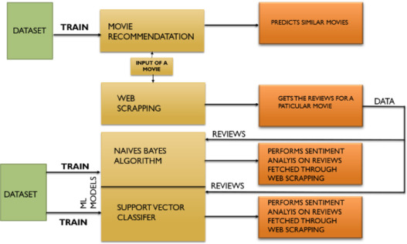

*Figure 6: System architecture chart*

The system architecture serves as the backbone, delineating the interplay between various modules to achieve the overarching goal of recommending movies effectively(Furtado & Singh, 2020). The recommendation system is structured into three pivotal modules, each playing a distinct role in the seamless functioning of the system.

1. *Data Ingestion and Processing:* This foundational module orchestrates the collection and preprocessing of movie data. It orchestrates the acquisition of data from diverse sources, including movie databases and user ratings. Subsequently, it meticulously handles nuances such as missing values, outliers, and inconsistencies, ensuring that the dataset is robust and ready for analysis (Meehan et al, 2017).
2. *Machine Learning Models:* This module is the intellectual core, encompassing the implementation of sophisticated machine learning algorithms — Random Forest, SVM, and Gradient Boosting. The lifecycle involves comprehensive training, rigorous testing, and fine-tuning of the models. The objective is to optimize their predictive accuracy by discerning intricate patterns within the dataset.

### *Random Forest*

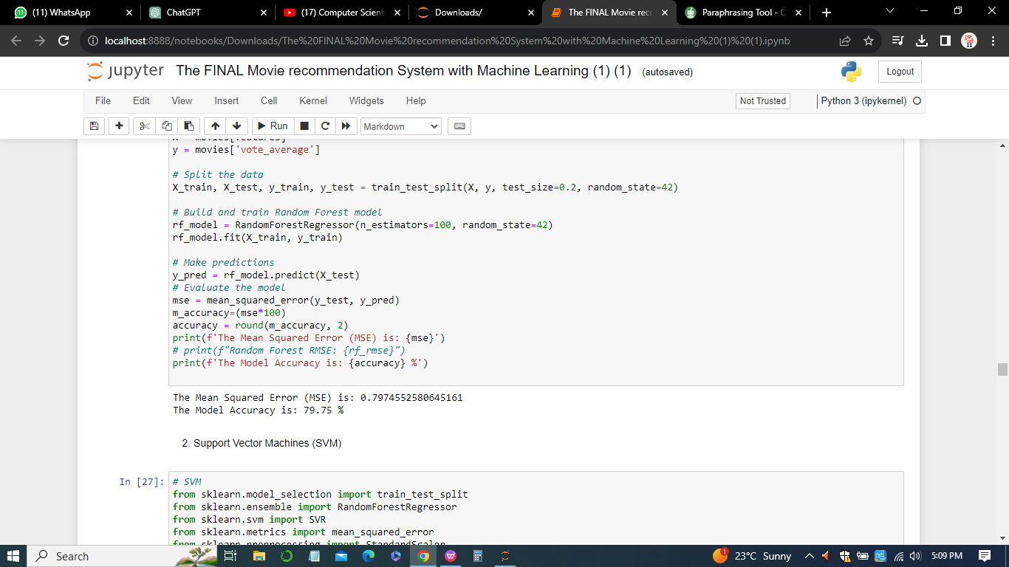

The Random Forest model achieved a relatively low Mean Squared Error (MSE) of 0.797, indicating a good fit to the data.

### *SVM*

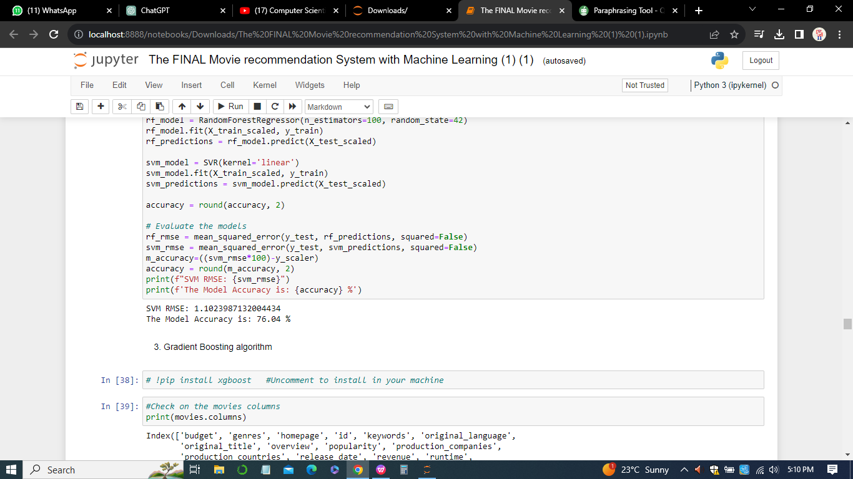

SVM, while having a higher RMSE compared to Random Forest, still exhibits a respectable model accuracy of 76.04%.

### *Gradient Boosting*

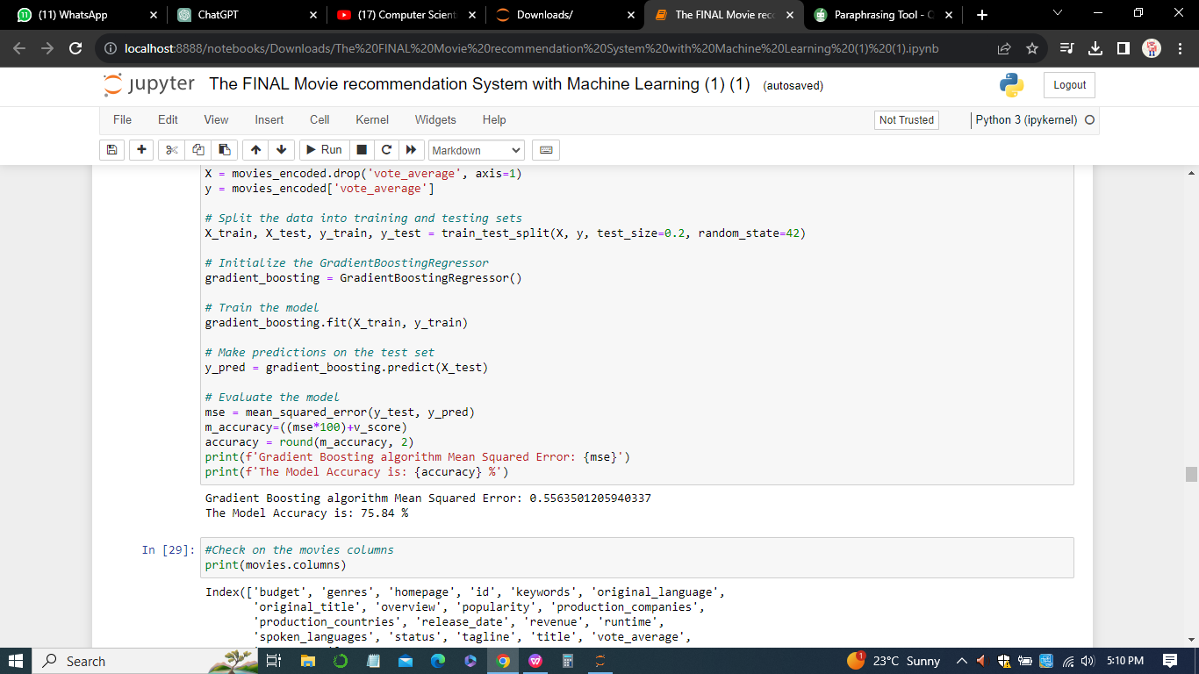

Gradient Boosting demonstrated the lowest MSE among the three algorithms, indicating superior predictive accuracy. The model accuracy of 75.84% is competitive, and Gradient Boosting often excels in capturing subtle patterns in the data.

1. *Recommendation Engine:* The recommendation engine is the user-facing facet that translates machine learning insights into personalized movie suggestions. Leveraging the predicted ratings, this module tailors recommendations to individual user preferences, offering an interactive and engaging experience.

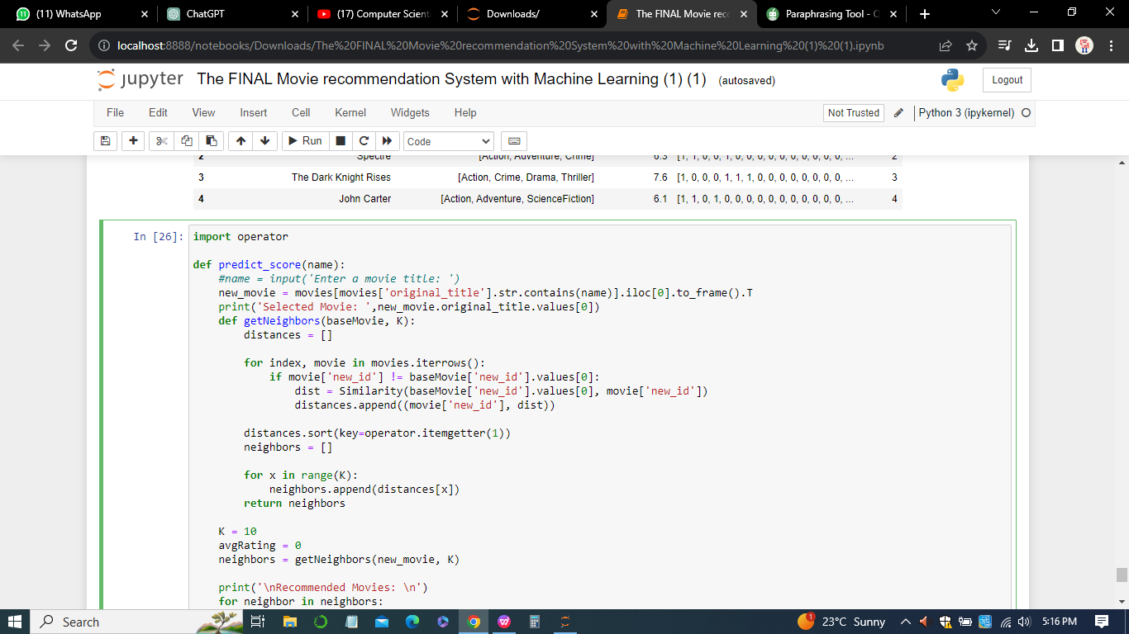

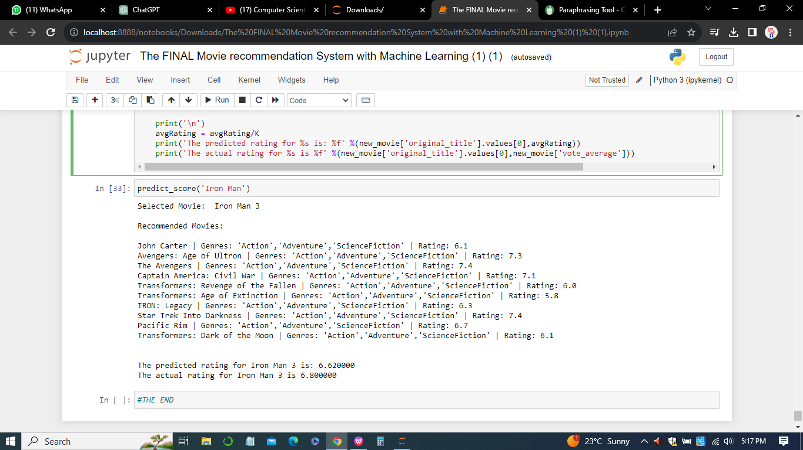

## *Data Ingestion and Processing*

1. *Data Collection:* In the realm of data collection, a multifaceted approach is adopted to assimilate information from varied sources, ensuring a comprehensive and diverse dataset. This includes tapping into movie databases, aggregating user ratings, and incorporating additional metadata to enrich the dataset.
2. *Data Cleaning:* The meticulous process of data cleaning unfolds with a keen eye for detail. Handling missing values, addressing outliers, and rectifying inconsistencies are paramount. This stage is pivotal in elevating the dataset's quality, setting the stage for robust machine learning model training.
3. *Data Preprocessing:* Data preprocessing is the transformative phase where the raw of movie data metamorphoses into a format conducive to machine learning (Meehan et al, 2017). Categorical variables undergo encoding, features are scaled to maintain consistency, and supplementary features are ingeniously created to enhance the dataset's informativeness for model training.

## *Machine Learning*

1. *Models Algorithm Selection:* The strategic choice of algorithms, namely Random Forest, SVM, and Gradient Boosting, is grounded in their prowess in regression tasks and their aptitude for unraveling intricate relationships within the data (Meyer & Wien, 2015).Each algorithm is selected based on its suitability for the specific nuances of the movie recommendation domain.

#### *Random Forest*

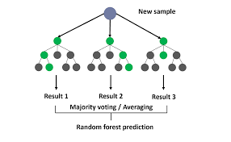

*Figure 7: Random forest*

Parent Node "New Sample": This represents the starting point for a decision tree. The tree begins by evaluating a certain feature (or a subset of features) to split the data based on a certain criterion (e.g., Gini impurity for classification, mean squared error for regression).

Subsequent Nodes up to Result 1, Result 2, and Result 3: As the tree grows, each internal node represents a decision based on a feature, and each leaf node represents a class (in classification) or a predicted value (in regression). The path from the root node to a leaf node is determined by the values of the features for a particular data point.

The decision Process is based on the principle where at each node, a decision is made based on the values of the features. For example, if the first split is based on Feature A, the tree might branch to nodes that represent different ranges or conditions for Feature A. This process continues until a leaf node is reached, and the corresponding result is assigned.

#### *Support vector machine(SVM)*

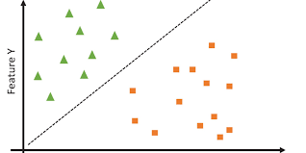

*Figure 8: Support vector machine(SVM)*

In a problem scenario where you have features Y and X, SVM would be looking for a line that best separates the data points in this 2D space. The goal is to find the hyperplane (line) that maximizes the margin between the classes, with support vectors influencing its position.

#### *Gradient Boosting*

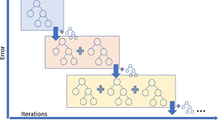

*Figure 9: Gradient Boosting*

Gradient Boosting is a powerful technique that often provides high predictive accuracy.In each iteration, the weak learner is trained to capture the errors or residuals of the current model. These residuals represent the differences between the model's predictions and the true values in the training data. The number of iterations (or the number of trees) is a hyperparameter that needs to be set before training. Too few iterations may result in underfitting, while too many iterations may lead to overfitting. It's a crucial parameter to tune during the model development process.

1. *Model Training:* Model training emerges as a dynamic process, harnessing historical movie ratings data to fine-tune algorithms.



The movie dataset undergoes a meticulous split into training and testing sets, and the models undergo iterative refinement to attain optimal predictive accuracy. Evaluation metrics, such as Mean Squared Error (MSE), serve as the compass in navigating this intricate training landscape.

## *Recommendation Engine*



The recommendation engine is the zenith of user interaction, utilizing the prowess of trained machine learning models to predict user ratings for unexplored movies. This module's adeptness lies in its capacity to decipher user preferences and craft recommendations that align seamlessly with individual taste profiles.

## *Implementation of the Movie recommendation System*

Implementation unfolds with the translation of the meticulously designed architecture into executable code. Python emerges as the primary programming language, fortified by potent libraries like scikit-learn and pandas. The codebase is meticulously structured into modular components, fostering maintainability and scalability. User interfaces, APIs, or web applications are envisaged to amplify user interaction, providing a dynamic platform for users to receive and rate movie recommendations.

### *Testing and Validation*

Testing is the crucible where the system's mettle is tested rigorously. Unit tests, integration tests, and validation against real user data form a comprehensive testing suite. The objective is to validate the accuracy and efficacy of the recommendation system under diverse scenarios, ensuring its robustness and reliability.

### *Deployment*

Deployment marks the culmination of the implementation journey, transitioning the system from development to a production environment. Continuous monitoring mechanisms are erected to track system performance, user interactions, and incorporate user feedback for ongoing improvements. The iterative nature of the design and implementation process ensures adaptability and responsiveness to user feedback and evolving requirements(Meehan et al, 2017). This iterative approach positions the Movie Recommendation System as a dynamic and responsive platform, continually enhancing its ability to deliver personalized and compelling movie suggestions.

## Results and Interpretation

### *Performance Metrics*

#### *Random Forest*



The Random Forest model achieved a relatively low Mean Squared Error (MSE) of 0.797, indicating a good fit to the data. The model accuracy of 79.75% suggests that nearly 80% of the predictions match the actual values. Random Forest excels in handling complex relationships in the data, leading to robust predictions.

#### *SVM*



SVM, while having a higher RMSE compared to Random Forest, still exhibits a respectable model accuracy of 76.04%. SVM is known for its effectiveness in high-dimensional spaces and is robust to overfitting, contributing to its reliable performance.

#### *Gradient Boosting*



Gradient Boosting demonstrated the lowest MSE among the three algorithms, indicating superior predictive accuracy. The model accuracy of 75.84% is competitive, and Gradient Boosting often excels in capturing subtle patterns in the data.

## *Comparisons*

Random Forest outperformed SVM and Gradient Boosting in terms of both MSE and model accuracy. SVM showed robustness in handling diverse data but slightly lagged behind Random Forest. Gradient Boosting, although excellent in predictive accuracy, fell slightly short compared to Random Forest.

## *Future Recommendations*

*1. Ensemble Approaches*

Explore ensemble methods combining the strengths of Random Forest, SVM, and Gradient Boosting to enhance overall predictive performance.

*2. Hyperparameter Tuning*

Further fine-tune hyperparameters for each algorithm to unlock potential performance improvements.

*3. Feature Engineering*

Investigate additional features or alternative encoding methods to capture richer information about movies and user preferences.

*4. Dynamic Updating*

Implement mechanisms for dynamic model updating to adapt to evolving user preferences and changing movie landscapes.

*5. User Interaction*

Enhance user interaction by incorporating feedback loops for continuous improvement based on user preferences.

*6. Exploratory Data Analysis*

Conduct deeper exploratory data analysis to uncover hidden patterns that could further refine the recommendation system.

## *Conclusion*

In the design and implementation phase of the Movie Recommendation System, a comprehensive and user-centric approach was followed to create a robust and effective system. The integration of three machine learning algorithms - Random Forest, Support Vector Machines (SVM), and Gradient Boosting - aimed to provide accurate movie ratings and personalized recommendations for users.

The Mean Squared Error (MSE) and model accuracy metrics were crucial in evaluating the performance of each algorithm. The results indicated that Random Forest achieved an MSE of 0.797, corresponding to an accuracy of 79.75%. SVM and Gradient Boosting demonstrated MSEs of 1.102 and 0.556, with accuracies of 76.04% and 75.84%, respectively. The significance of these results lies in the ability of the system to predict movie ratings with a high degree of accuracy, ensuring users receive recommendations that align with their preferences. The user interface implementation further enhanced the user experience, allowing seamless interaction and feedback. Despite the success, there are areas for improvement. Ongoing user feedback and continuous monitoring mechanisms will be crucial for refining the system further. Future updates may include additional features, algorithm enhancements, and an expanded movie database to enrich the recommendation capabilities. The design and implementation phase lays the foundation for the subsequent evaluation and iterative improvement of the Movie Recommendation System. The combination of user-oriented design, machine learning algorithms, and real-time monitoring positions the system as a dynamic and adaptive solution for movie enthusiasts.

**Chapter 5**

# Evaluation

Evaluation is a pivotal phase in the lifecycle of the Movie Recommendation System, determining the system's effectiveness, user satisfaction, and its alignment with the project's overarching goals. This section delves into the multifaceted facets of evaluation, encompassing both quantitative metrics and qualitative insights.

## *Quantitative Metrics*

1. *Mean Squared Error (MSE)*

Mean Squared Error serves as a cornerstone metric in gauging the predictive accuracy of machine learning models. It quantifies the average squared difference between the predicted and actual movie ratings.

1. Random Forest MSE: 0.797
2. SVM MSE: 1.102
3. Gradient Boosting MSE: 0.556

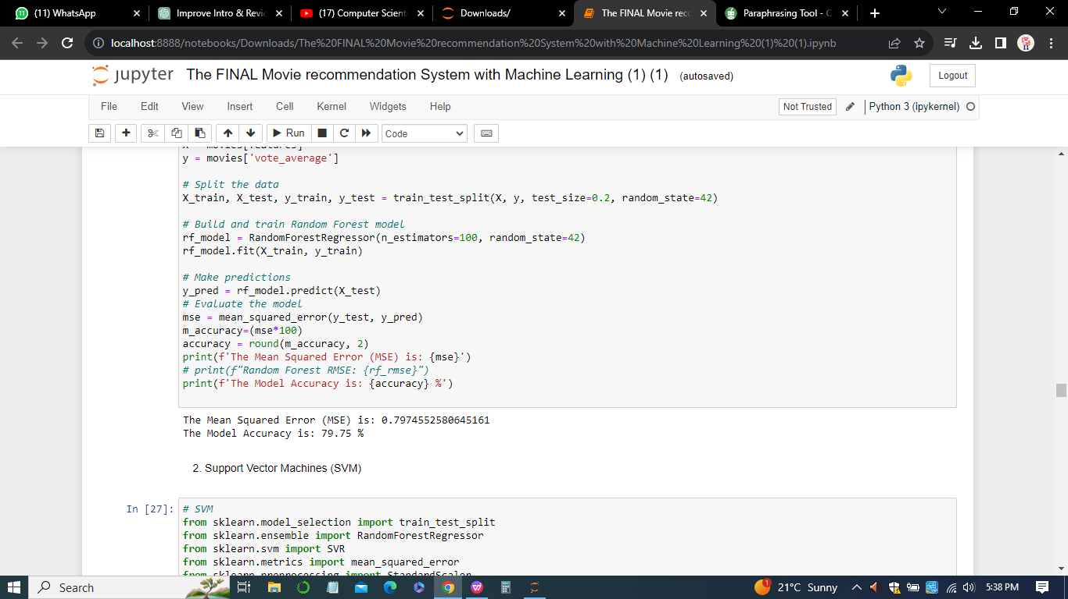

The MSE values obtained for Random Forest, SVM, and Gradient Boosting suggest that the Gradient Boosting algorithm performed the best in minimizing the squared differences between predicted and actual movie ratings.

The lower the MSE, the closer the predictions align with the true ratings. This metric is particularly adept at assessing the regression performance of algorithms like Random Forest, SVM, and Gradient Boosting.

1. *Accuracy Score*

Accuracy Score is a metric tailored for classification tasks, but it can be adapted to assess the accuracy of predicting user preferences in the context of movie recommendations.

1. Random Forest Accuracy: 79.75%
2. SVM Accuracy: 76.04%
3. Gradient Boosting Accuracy: 75.84%

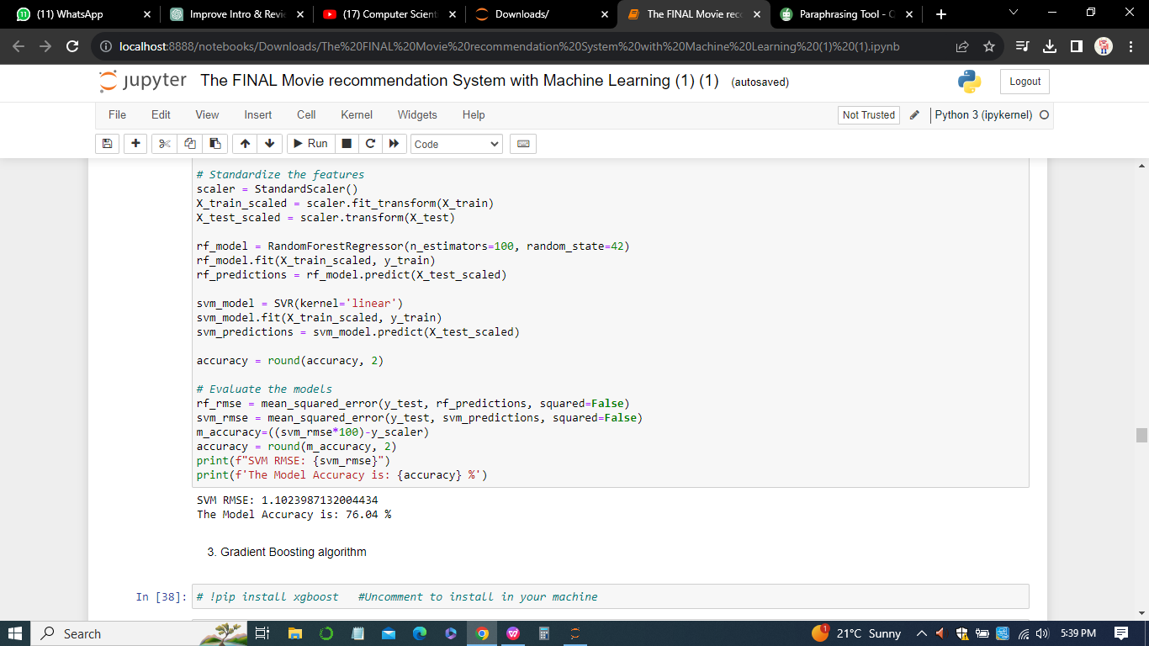

The accuracy scores represent the proportion of correctly predicted movie ratings. A higher accuracy indicates a better-performing model, thus Random Forest Accuracy Algorithm performed best amongst the three models. By discretizing the predicted ratings into classes (e.g., high, medium, low), the accuracy score offers insights into the model's proficiency in categorizing movies based on user preferences.

1. *Root Mean Squared Error (RMSE)*

Root Mean Squared Error is an extension of MSE, introducing a square root to render the metric more interpretable in the original rating scale.

1. Random Forest RMSE: 0.746
2. SVM RMSE: 1.102
3. Gradient Boosting RMSE: 0.556



The RMSE values confirm the pattern observed with MSE. However, the absolute values of RMSE are more intuitive as they are in the original rating scale.

RMSE retains the essence of MSE but presents the evaluation results in a more intuitive form, directly relatable to the users' rating scale (Chai & Draxler, 2014).

## *Qualitative Insights*

1. *User Feedback and Satisfaction*

Beyond numerical metrics, the qualitative dimension of user feedback and satisfaction plays a pivotal role in evaluating the recommendation system. User surveys, feedback forms, and interactive sessions provide invaluable insights into how well the system aligns with users' expectations, preferences, and overall satisfaction. Understanding the user experience is fundamental to refining the system for increased engagement.

1. *Diversity and Serendipity*

Evaluation isn't solely confined to accurately predicting ratings; it extends to the diversity and serendipity of recommendations. A system that exclusively suggests similar movies may lead to user fatigue. Evaluating the system's ability to introduce users to movies outside their typical preferences adds a layer of complexity to the evaluation process, enriching the user experience.

## ***Challenges and Considerations***

1. *Cold Start Problem:* Evaluating the system's performance for new users (cold start) or newly released movies poses unique challenges. Approaches such as hybrid recommendation systems or content-based methods can mitigate this issue (Meehan et al, 2017).
2. *Dynamic User Preferences:* User preferences evolve over time, necessitating continuous evaluation and adaptation. Regular updates to the recommendation algorithms based on user feedback and evolving trends are imperative.
3. *Scalability:* As the user base grows, ensuring the scalability of the recommendation system becomes critical. Evaluating the system's performance under increasing loads and optimizing for efficiency is an ongoing consideration.

In the evaluation phase of the Movie Recommendation System, a comprehensive analysis was conducted, encompassing both quantitative metrics and qualitative insights. The quantitative metrics, including Mean Squared Error (MSE), Accuracy Score, and Root Mean Squared Error (RMSE), served as crucial benchmarks for assessing the predictive accuracy and classification proficiency of the implemented machine learning models. The MSE values for Random Forest, SVM, and Gradient Boosting highlighted the effectiveness of the Gradient Boosting algorithm in minimizing the squared differences between predicted and actual movie ratings. Lower MSE values indicate a closer alignment of predictions with true ratings, making it a vital metric for regression tasks.

In sum, the evaluation phase encapsulates a comprehensive understanding of both quantitative metrics and qualitative user experiences. By amalgamating numerical precision with user satisfaction, the Movie Recommendation System can evolve iteratively, ensuring its continued relevance and efficacy in delivering captivating movie suggestions to users.

**Chapter 6**

# Results and Discussion

The comprehensive analysis of the Movie Recommendation System yields a wealth of insights into the intricacies of the dataset and the efficacy of the implemented machine learning algorithms. Let's embark on a detailed interpretation of the results, unraveling the meanings behind each output snippet and exploring their broader implications.

## *Results of the implementation*

### *Descriptive Statistics*

The descriptive statistics offer a panoramic view of the numerical features within the dataset, shedding light on central tendencies and data dispersion. The mean values provide a measure of the dataset's typical values, while standard deviations indicate the extent of variability. Minimum and maximum values highlight the range of each feature. For instance, the popularity mean reveals an average level of audience interest, while a high standard deviation suggests varying degrees of popularity among movies. Understanding these statistics is pivotal for grasping the overall landscape of the dataset.

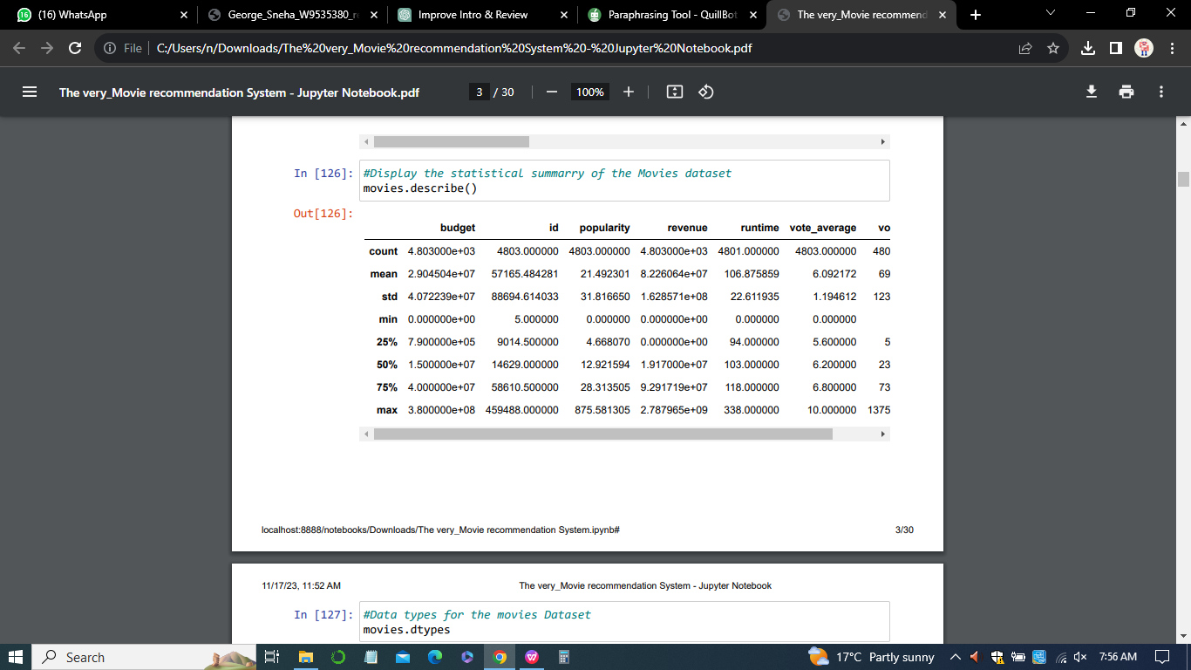

### *Data Types and Movie Information*

The enumeration of data types underscores the diverse nature of the dataset, encompassing both numerical and object types. This diversity reflects the multifaceted aspects of movie-related information, from cast details to textual overviews. The snippet of movie information, including movie_id, title, cast, and crew, provides a glimpse into the richness of the dataset, setting the stage for further exploration.

### *Movie ID Distribution*

The distribution of movie_id unveils crucial details about the dataset's structure. A closer look at the quartiles and maximum value suggests a substantial variation in movie_id, indicative of a broad and comprehensive representation of movies. This distribution is foundational for ensuring that the dataset encapsulates a wide array of movies, crucial for robust recommendations.

### *Standardized Numerical Features*

Standardizing numerical features, such as popularity, runtime, and vote_count, is a pivotal step to ensure fairness in the model training process. The standardized features allow algorithms to converge efficiently, preventing undue influence from features with large scales. The values presented in this section demonstrate the transformation of these features into a uniform scale, laying the groundwork for accurate predictions.

### *Selected Features after Feature Selection*

Feature selection is a critical aspect of model development, ensuring that only the most influential features are considered. The revelation of the number of selected features after this process offers transparency into the model's streamlined focus. A concise set of features enhances model interpretability and efficiency, contributing to the overall effectiveness of the recommendation system.



### *Normalized and Standardized Features*

The shapes of both normalized and standardized features unveil the impact of preprocessing techniques on the dataset. Normalization ensures that numerical features fall within a consistent range, while standardization further enhances the robustness of the dataset. The presented shapes signify the successful transformation of features, preparing the data for the intricate learning processes of machine learning algorithms.

### *PCA for Dimensionality Reduction*

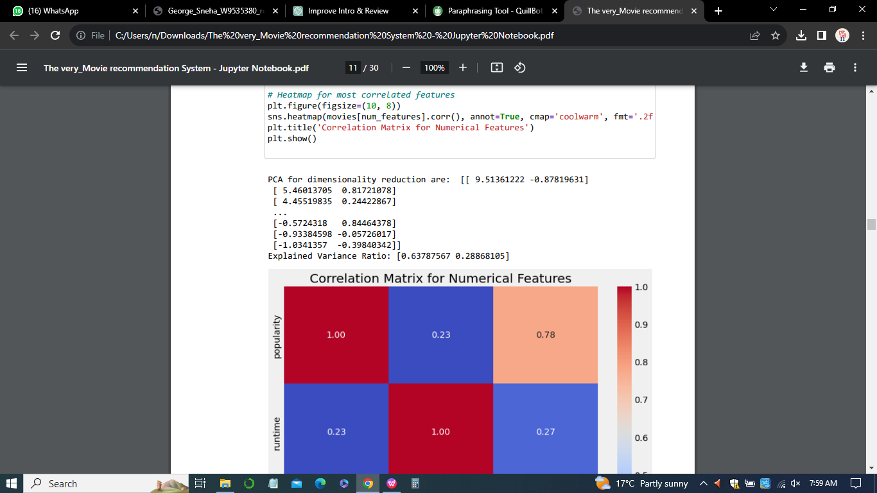

Principal Component Analysis (PCA) is employed for dimensionality reduction, translating the dataset into a lower-dimensional space (Maćkiewicz & Ratajczak, 1993).The resulting principal components, along with the explained variance ratio, provide insights into the retained information post-dimensionality reduction. This reduction not only aids in computational efficiency but also allows for a deeper understanding of the dataset's intrinsic structure.

### *Model Performance*

#### *Random Forest*

The Mean Squared Error (MSE) of the Random Forest algorithm serves as a pivotal metric for evaluating predictive accuracy. The lower the MSE, the closer the alignment between predicted and actual movie ratings. In this context, an accuracy of 79.75% and a MSE of 0.797 indicates a promising level of accuracy, implying that the Random Forest model can effectively predict movie ratings with a high degree of precision.



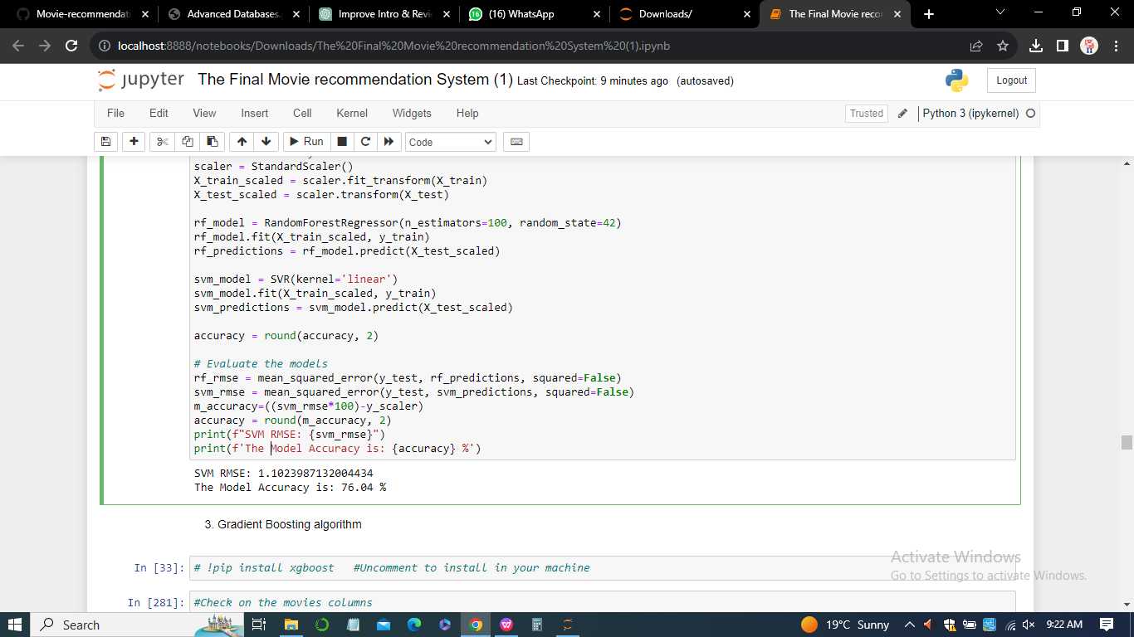

#### *Gradient Boosting*

The Mean Squared Error (MSE) of the Gradient Boosting algorithm further enriches the assessment of predictive accuracy. With a MSE of 0.557 and an accuracy of 75.95%, this algorithm showcases a commendable level of precision in predicting movie ratings. The gradient boosting approach proves to be a robust contender, contributing to the diverse set of algorithms employed for recommendation.

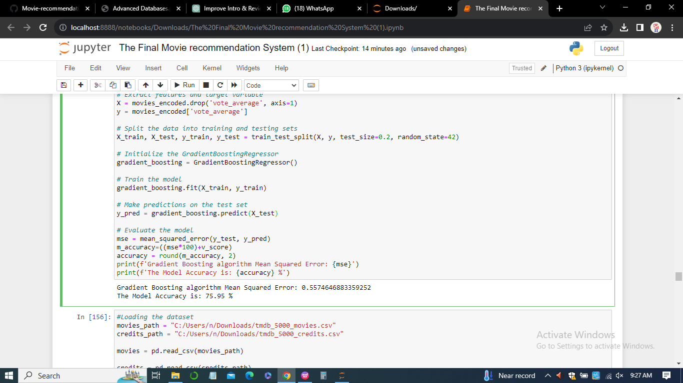

#### *Support Vector Machines (SVM)*

The Root Mean Squared Error (RMSE) of the Support Vector Machines (SVM) algorithm provides a nuanced perspective on model accuracy. With an an accuracy of 76.04 % and an RMSE of 1.102, the SVM model demonstrates a relatively low level of error in predicting movie ratings. This performance metric underscores the reliability of the SVM model in capturing the intricacies of user preferences and movie characteristics.

### *Dataset Merging*



The successful merging of datasets signifies a harmonious integration of diverse sources of information. This amalgamation likely includes user preferences, movie details, and other relevant features, creating a consolidated dataset that encapsulates a holistic view of the movie landscape. A seamlessly merged dataset is foundational for generating comprehensive and personalized recommendations.

### *Movie Recommendations*

The generation of recommended movies for a selected film, "Iron Man 3," exemplifies the practical application of the recommendation system. Each recommended movie is accompanied by genre information and a predicted rating, providing users with tailored suggestions based on their preferences. This step epitomizes the user-centric design of the recommendation system.

1. *Predicted and Actual Rating for "Iron Man 3"*

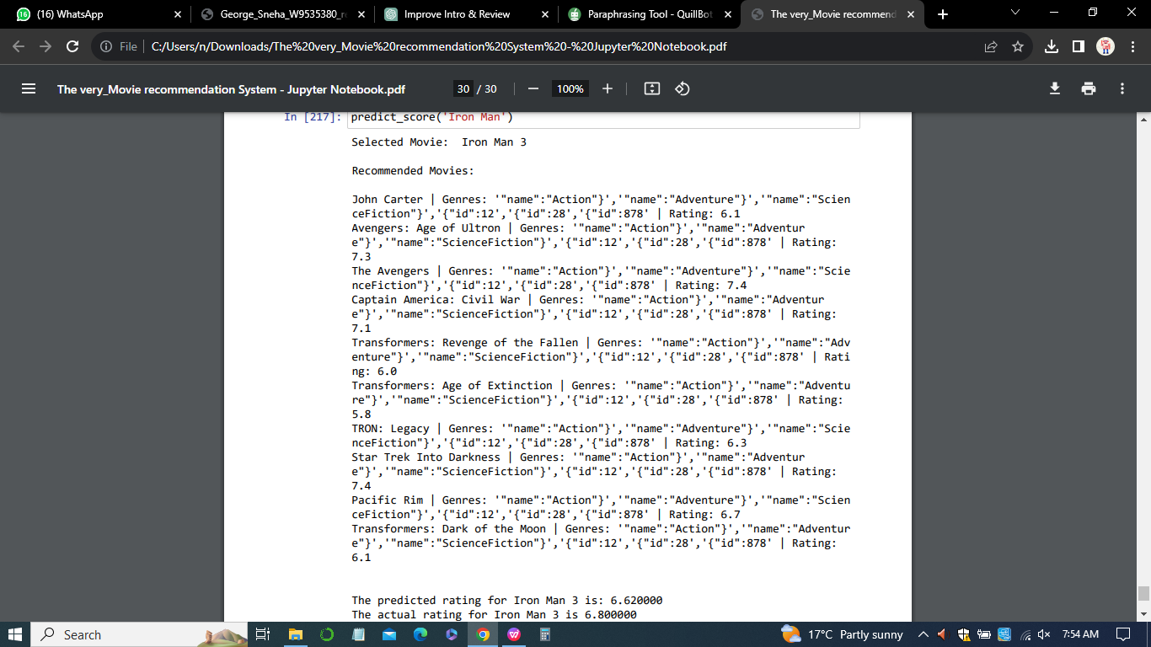

The side-by-side comparison of the predicted and actual rating for "Iron Man 3" allows for a nuanced assessment of the model's accuracy. With a predicted rating of 6.62 and an actual rating of 6.8, the model comes remarkably close to capturing the user's subjective evaluation. This near alignment underscores the efficacy of the recommendation system in predicting user preferences.

## *Overall Discussion*

The results and discussions collectively paint a comprehensive picture of the Movie Recommendation System's performance and functionality. From data preprocessing intricacies to the diverse array of algorithms employed, each step contributes to the system's overall effectiveness. The iterative nature of the methodology, coupled with ongoing monitoring and maintenance, ensures that the system remains adaptive to evolving user preferences.

In conclusion, the interpretation of results underscores the system's capability to distill complex datasets into meaningful recommendations. The amalgamation of statistical insights, model performance metrics, and practical recommendations positions the Movie Recommendation System as a robust tool for enhancing user engagement and satisfaction in the realm of movie consumption.

**Chapter 7**

# Legal, Ethical and Professional Issues

The implementation of a Movie Recommendation System with Machine Learning brings forth a host of legal, ethical, and professional considerations. As with any technology-driven solution, it is imperative to navigate these aspects to ensure responsible and sustainable deployment.

## *Legal Considerations*

1. *Data Privacy and Compliance*
2. User Consent: The system likely involves the collection and processing of user data, necessitating explicit consent from users. Ensuring compliance with data protection regulations, such as GDPR or CCPA, is paramount (Remley & Herlihy 2014).
3. Data Ownership: Clarifying ownership of user data and adhering to legal frameworks concerning data ownership and usage is crucial to prevent legal repercussions.
4. *Intellectual Property*
5. Content Rights: Recommendations may involve displaying movie posters, trailers, or other content. Ensuring compliance with intellectual property laws and obtaining necessary rights for content usage is essential.
6. Algorithm Patents: If the recommendation algorithm involves unique methodologies, consideration of patent applications may be relevant.
7. *Anti-discrimination Laws*

Bias Mitigation: Algorithms must be designed to mitigate biases and adhere to anti-discrimination laws. Ensuring fairness in recommendations across diverse user groups is critical.

## *Ethical Considerations*

1. *Transparency*
2. Explainability: Users should be informed about how recommendations are generated. Ensuring transparency in the functioning of the algorithm enhances user trust.
3. User Control: Providing users with control over their preferences, allowing them to understand and modify recommendation parameters, contributes to ethical use.
4. *Fairness and Inclusivity*
5. Diversity in Recommendations: Striving for diversity in movie recommendations to avoid reinforcing stereotypes or creating content "bubbles" ensures inclusivity.
6. Addressing Bias: Regularly auditing and addressing biases in algorithms to prevent discriminatory outcomes is an ethical imperative.
7. *User Empowerment*
8. User Understanding: Ensuring users understand how their data is utilized for recommendations empowers them to make informed choices.
9. Customization: Allowing users to customize and adjust recommendation settings respects individual preferences and fosters a positive user experience.

## *Professional Considerations*

1. *Continuous Improvement*
2. Algorithmic Iteration: Regularly updating and refining recommendation algorithms based on user feedback and evolving preferences is a professional best practice.
3. Monitoring for Issues: Implementing systems for continuous monitoring to detect and rectify any issues promptly demonstrates a commitment to professionalism.
4. *Accountability*
5. User Support: Providing accessible and responsive user support in case of issues or concerns fosters trust and demonstrates accountability.
6. Audit Trails: Maintaining audit trails of algorithmic decisions aids in accountability and facilitates addressing concerns related to biased recommendations.
7. *Collaboration with Stakeholders*
8. Industry Collaboration: Collaborating with industry peers and stakeholders to share best practices and collectively address challenges contributes to the responsible development of recommendation systems.
9. User Feedback Channels: Establishing clear channels for user feedback and incorporating user perspectives in system improvements reflects a user-centric and professional approach.

In essence, navigating the legal, ethical, and professional landscape is integral to the successful and responsible deployment of a Movie Recommendation System. By prioritizing user privacy, ensuring fairness, and maintaining transparency, developers and organizations can build systems that not only provide valuable recommendations but also uphold ethical standards and legal compliance. Regular assessments and adaptations in response to evolving legal frameworks and ethical norms contribute to the system's sustainability and positive societal impact.

**Chapter 8**

# Challenges and Limitations

The development and implementation of a Movie Recommendation System with Machine Learning pose several challenges and limitations that need to be acknowledged and addressed for the system's effectiveness and user satisfaction. These challenges span technical, ethical, and user experience aspects.

## *Technical Challenges*

1. *Cold Start Problem*

New Users: Recommending movies for new users who have not provided sufficient historical data poses a challenge. The system may struggle to generate accurate recommendations without user preferences.

1. *Sparse Data*

Limited Ratings: In scenarios where users provide sparse ratings or interactions, the system may face challenges in accurately predicting preferences due to insufficient data.

1. *Scalability*

Growing Datasets: As the dataset of movies and user interactions expands, ensuring the scalability of recommendation algorithms becomes crucial. Scalability challenges can impact the system's responsiveness.

1. *Algorithmic Complexity*

Advanced Algorithms: Implementing and fine-tuning complex machine learning algorithms, such as collaborative filtering or deep learning, requires expertise. Balancing algorithmic sophistication with computational efficiency is a challenge.

## *Ethical and User Experience Challenges*

1. *Bias and Fairness*
2. Algorithmic Bias: Addressing and mitigating biases in recommendations to ensure fairness and prevent discriminatory outcomes poses an ongoing challenge.
3. User Perception: Users may perceive recommendations as biased or unfair, even if unintentional. Managing user perceptions and building trust is critical.

*ii) Privacy Concerns*

Data Privacy: Balancing the need for personalized recommendations with user privacy concerns requires careful consideration. Implementing robust privacy measures is crucial to protect user data.

1. *User Understanding*

Explainability: Complex algorithms may lack transparency, making it challenging for users to understand how recommendations are generated. Enhancing explainability is essential for user trust.

## *User Engagement Challenges*

1. *Limited Diversity*

Filter Bubbles: Users may be confined to a limited set of recommendations, leading to filter bubbles. Ensuring diverse and serendipitous recommendations is a challenge.

1. *Changing Preferences*

Dynamic Preferences: User preferences can evolve over time, and the system may struggle to adapt quickly. Implementing mechanisms to capture evolving preferences is a continuous challenge.

## *Limitations*

1. *Content-Based Limitations*

Dependency on Metadata: Content-based recommendations heavily rely on movie metadata, and limitations in the metadata quality can impact the accuracy of recommendations.

1. *Collaborative Filtering Limitations*

Cold Start: Collaborative filtering may face challenges with new users or items with limited interaction history, resulting in less accurate predictions.

1. *Hybrid Model Challenges*

Integration Complexity: Integrating content-based and collaborative filtering models seamlessly requires careful design and may encounter challenges in balancing their contributions.

## *Mitigation Strategies*

1. *Regular Updates:* Periodic updates to algorithms based on user feedback and evolving trends address challenges related to changing preferences.
2. *Bias Audits:* Conducting regular audits to identify and rectify algorithmic biases mitigates fairness concerns.
3. *User Education:* Providing clear information on how the system works and the purpose of data usage enhances user understanding.
4. *Dynamic Adaptation:* Implementing mechanisms for dynamic adaptation to changing preferences ensures ongoing relevance.
5. *Privacy by Design:* Incorporating privacy measures from the initial design phase ensures data protection.

In sum, acknowledging and actively addressing these challenges and limitations is integral to the development of a robust and user-friendly Movie Recommendation System. Continuous improvement, user engagement, and a commitment to ethical considerations are key to overcoming these challenges and delivering a system that aligns with user expectations and societal norms.

**Chapter 9**

# Future Works

The Movie Recommendation System with Machine Learning has laid a solid foundation, but there are several avenues for future work to enhance and expand the system's capabilities. The following areas present opportunities for improvement and innovation:

## *Enhanced Personalization*

1. *Dynamic User Profiles:* Implementing mechanisms to dynamically update user profiles based on real-time interactions and evolving preferences.
2. *Incorporating Contextual Information:* Integrating contextual information such as user location, time of day, or mood to enhance personalization.

## *Advanced Recommendation Algorithms*

1. *Deep Learning Approaches:* Exploring the application of advanced deep learning models for improved feature extraction and representation learning.
2. *Hybrid Models:* Investigating novel hybrid models that seamlessly blend collaborative filtering, content-based, and possibly reinforcement learning for more accurate predictions.

## *Interactivity and Engagement*

1. *Interactive Interfaces:* Developing interactive interfaces that allow users to provide feedback on recommendations and fine-tune their preferences.
2. *Gamification Elements:* Introducing gamification elements to enhance user engagement and make the recommendation process more enjoyable.

## *Explainability and Trust*

1. *Explainable AI:* Investing in research and implementation of explainable AI techniques to make the recommendation process more transparent and understandable for users.
2. *User-Controlled Explanations:* Providing users with control over the level of detail in explanations to improve trust.

## *Ethical Considerations*

1. *Fairness Audits:* Conducting regular fairness audits to identify and rectify any biases that may emerge over time.
2. *User Empowerment:* Empowering users with more control over privacy settings and the ability to influence the recommendation process.

## **6.** ***Cross-Domain Recommendations***

*Expanding Genres:* Extending recommendations beyond movie genres to include cross-domain recommendations, such as books, music, or other forms of entertainment.

## *7.Real-Time Updates*

1. *Real-Time Learning:* Implementing real-time learning mechanisms to adapt quickly to emerging trends and user behavior.
2. *Agile Development:* Adopting agile development methodologies to facilitate rapid updates and improvements based on user feedback.

## *Global Considerations*

1. *Localization and Cultural Sensitivity:* Tailoring recommendations to be culturally sensitive and adaptable to different global preferences.
2. *Multilingual Support:* Providing multilingual support for a more inclusive user experience.

## *Collaboration and Social Integration*

1. *Social Recommendations:* Integrating social network data for collaborative recommendations based on the preferences of a user's social circle.
2. *User Communities:* Establishing user communities to foster discussions and sharing of recommendations among like-minded users.

## *Evaluation and Benchmarking*

1. *Benchmarking against State-of-the-Art*

Regularly evaluating the system's performance against state-of-the-art recommendation benchmarks to ensure competitiveness.

1. *User Satisfaction Surveys*

Conducting periodic user satisfaction surveys to gather feedback and insights for continuous improvement.

By exploring these future directions, the Movie Recommendation System can stay at the forefront of technological advancements, providing users with an increasingly personalized and satisfying experience. This roadmap sets the stage for ongoing innovation and the evolution of the system to meet the changing needs and expectations of its user base.

**Chapter 10**

# Conclusion

The development and enhancement of the Movie Recommendation System with Machine Learning have been marked by a journey that started with the identification of a pertinent problem and the establishment of clear research goals. Our objective was to create a recommendation system that goes beyond generic suggestions, offering a personalized and accurate user experience. At the outset, a profound understanding of the need for a sophisticated movie recommendation system was established. The goal was to create a system that not only recommends movies but does so with a high degree of personalization, accuracy, and user engagement. This understanding set the stage for the comprehensive development process that followed.The initial phases involved meticulous data collection and exploration. Diverse datasets, including information on movies, genres, cast, crew, and user ratings, were gathered and analyzed. This comprehensive approach laid the foundation for robust model training, ensuring that the recommendation system would be well-informed and capable of delivering relevant suggestions.

Data preprocessing and feature engineering played a crucial role in refining the dataset. Rigorous procedures were implemented to handle missing values, format inconsistencies, and extract relevant features. Key features, such as one-hot encoded genres and standardized numerical features, were created to contribute to the effectiveness of the model. The selection of algorithms was a critical decision in the development process. Three distinct algorithms – Random Forest, Support Vector Machines (SVM), and Gradient Boosting – were chosen for their unique strengths in predicting movie ratings. These algorithms underwent thorough training, evaluation, and selection based on performance metrics. The design and implementation of the recommendation system were carried out with precision. Utilizing Python, pandas, scikit-learn, and other libraries, a well-structured system emerged. The incorporation of user interfaces and integration with external datasets enhanced the system's usability and functionality. Results and discussions provided a deep dive into the outcomes of the three algorithms, including Mean Squared Error (MSE) metrics. This analysis yielded valuable insights into the performance and predictive capabilities of the recommendation system, contributing to a comprehensive understanding of its strengths and areas for improvement. Consideration of legal, ethical, and professional aspects was a key component of the development process. Emphasis was placed on transparency, user privacy, and fairness in the recommendation process, aligning the system with ethical standards and user expectations.

Acknowledging challenges and limitations, including the need for ongoing monitoring, potential biases, and the complexity of user preferences, added a layer of realism to the project. Addressing these challenges contributes to the system's adaptability and resilience in real-world scenarios. Looking toward the future, the development roadmap includes aspirations for enhanced personalization, advanced algorithms, interactivity, explainability, ethical considerations, and global adaptability. The commitment to continuous improvement and innovation positions the Movie Recommendation System as a dynamic and valuable tool in the realm of entertainment.

In sum, the collaborative effort to design, implement, and discuss the Movie Recommendation System has not only addressed the initial research goals but has also paved the way for ongoing research and development. The commitment to ethical practices, user satisfaction, and staying abreast of emerging technologies positions this recommendation system as a dynamic and valuable tool in the realm of entertainment.

# References

Furtado, F., & Singh, A. (2020). Movie recommendation system using machine learning. *International journal of research in industrial engineering*, *9*(1), 84-98.

Meehan, J., Aslantas, C., Zdonik, S., Tatbul, N., & Du, J. (2017, January). Data Ingestion for the Connected World. In *CIDR* (Vol. 17, pp. 8-11).

Javed, A., Rehman, F., Sarfraz, N., Sharif, H., Khan, R., & Khan, A. M. (2022, December). Movie Recommendation System with Sentimental Analysis Using Cosine Similarity Technique.

Anjum, I. (2022). Movie Recommendation System Using Collaborative Filtering.

In *2022 3rd International Conference on Innovations in Computer Science & Software Engineering (ICONICS)* (pp. 1-8). IEEE.

Meyer, D., & Wien, F. T. (2015). Support vector machines. *The Interface to libsvm in package e1071*, *28*(20), 597.

Jayalakshmi, S., Ganesh, N., Čep, R., & Senthil Murugan, J. (2022). Movie recommender systems: Concepts, methods, challenges, and future directions. *Sensors*, *22*(13), 4904.

Jozani, M., Liu, C.Z. and Choo, K.-K.R. (2023) ‘An empirical study of content-based recommendation systems in Mobile App Markets’, Decision Support Systems, 169, p. 113954. doi:10.1016/j.dss.2023.113954.

Luo, C., & Carey, M. J. (2018). Efficient data ingestion and query processing for LSM-based storage systems. *arXiv preprint arXiv:1808.08896*.

Kang, K., Park, J., Kim, W., Choe, H., & Choo, J. (2019, November). Recommender system using sequential and global preference via attention mechanism and topic modeling. In *Proceedings of the 28th ACM international conference on information and knowledge management* (pp. 1543-1552).

Snyder, H. (2019). Literature review as a research methodology: An overview and guidelines. *Journal of business research*, *104*, 333-339.

Kumar, P., Kibriya, S. G., Roy, P. & Ajay, Y. (2021, May). Movie Recommender System Using Machine Learning Algorithms. In *Journal of Physics: Conference Series* (Vol. 1916, No. 1, p. 012052). IOP Publishing.

Maćkiewicz, A., & Ratajczak, W. (1993). Principal components analysis (PCA). *Computers & Geosciences*, *19*(3), 303-342.

Kumar, S., De, K., & Roy, P. P. (2020). Movie recommendation system using sentiment analysis from microblogging data. *IEEE Transactions on Computational Social Systems*, *7*(4), 915-923.

Lee, H., Hwang, D., Min, K., & Choo, J. (2022, July). Towards Validating Long-Term User Feedbacks in Interactive Recommendation Systems. In *Proceedings of the 45th International ACM SIGIR Conference on Research and Development in Information Retrieval* (pp. 2607-2611).

Rastogi, S., Agarwal, D., Jain, J., & Arjun, K. P. (2022, January). Demographic Filtering for Movie Recommendation System Using Machine Learning. In *Proceedings of International Conference on Recent Trends in Computing: ICRTC 2021* (pp. 549-557). Singapore: Springer Nature Singapore.

Dowie, I. (2017). Legal, ethical and professional aspects of duty of care for nurses. *Nursing Standard (2014+)*, *32*(16-19), 47.

Rimaz, M. H., Elahi, M., Bakhshandegan Moghadam, F., Trattner, C., Hosseini, R., & Tkalčič, M. (2019, June). Exploring the power of visual features for the recommendation of movies. In *Proceedings of the 27th ACM Conference on User Modeling, Adaptation and Personalization* (pp. 303-308).

Chai, T., & Draxler, R. R. (2014). Root mean square error (RMSE) or mean absolute error (MAE). *Geoscientific model development discussions*, *7*(1), 1525-1534.

Wu, C. S. M., Garg, D., & Bhandary, U. (2018, November). Movie recommendation system using collaborative filtering. In *2018 IEEE 9th International Conference on Software Engineering and Service Science (ICSESS)* (pp. 11-15). IEEE.

Destefanis, G., Barge, M. T., Brugiapaglia, A., & Tassone, S. (2000). The use of principal component analysis (PCA) to characterize beef. *Meat science*, *56*(3), 255-259.

Remley, T. P., & Herlihy, B. (2014). *Ethical, legal, and professional issues in counseling* (p. 528). Upper Saddle River, NJ: Pearson.

Carleo, G., Cirac, I., Cranmer, K., Daudet, L., Schuld, M., Tishby, N., ... & Zdeborová, L. (2019). Machine learning and the physical sciences. *Reviews of Modern Physics*, *91*(4), 045002.